Tutorial 8

**Website Case Study**

**JavaJam Coffee House**

In this case study, you will configure the website to display in mobile devices using the single-column layout. You will code media queries for mobile styles; modify the current desktop styles; and update the Home, Menu, and Music pages.

**Task 1: Modify the Home Page.**

1. Configure a viewport meta tag that configures the width to the device-width and sets the initial-scale to 1.0.
2. The homepage displays a phone number in the contact information area. Wouldn’t it be handy if a person using a smartphone could click on the phone number to call the coffee house? You can make that happen by using tel: in a hyperlink. Configure a hyperlink assigned to an id named mobilethat contains the phone number (1-888-555).
3. But wait a minute, a telephone link could confuse those visiting the site with a desktop browser. Code another phone number directly after the hyperlink. Code a span element assigned to an id named desktop around the phone number.

* Don’t worry about the two phone numbers that are now on the page. You’ll configure CSS in Task 4 and 6 to show the appropriate phone number to your website visitors.

**Task 2: Modify the Menu page.** Add the viewport meta tag in a manner consistent with the home page. Use the HTML validator to help you find syntax errors.

**Task 3: Modify the Music page.** Add the viewport meta tag in a manner consistent with the home page. Use the HTML validator to help you find syntax errors.

**Task 4: Modify the Desktop CSS.** Configure the CSS for the phone number display as shown below:

#mobile { display: none; }  
#desktop { display: inline; }

**Task 5: Configure the Tablet CSS.** Open the javajam.css in a text editor. Edit the style as follows:

1. Code a media query to select for typical tablet device viewport size.
2. Code the following new styles within the media query:
3. Configure a body element selector with margin set to 0. Set the background-image property to none.
4. Configure the wrapper id selector. Set the width to auto, min-width to 0, margin to 0, and box-shadow to none.
5. Configure the header element selector. Configure a 5px solid #FEF6C2 bottom border.
6. Configure the h1 element selector. Set top margin to 0, bottom margin to 1em, top padding to 1em, bottom padding to 1em, and 2.5em font size.
7. Configure the nav element selector. The mobile layout uses a single column. Set the float to none, auto width, 0 top padding, 10px margin, and 1.3em font size.
8. Configure the nav li selector. Set display to inline-block.
9. Configure the nav a selector. Set padding to 1em, width to 8em, font weight to bold, and border-style to none.
10. Configure the nav ul element selector with 0 padding and margin.
11. Configure the main element selector. Set padding to 0, margin to 0, and font size to 90%.

**Task 6: Configure the Smartphone CSS.** In this task you will code additional styles needed for smaller devices. Note that any device with a screen max-width of 1024 pixels or less will apply the styles you coded in Task 5. Edit the styles rules as follows:

1. Code a media query to select for typical smartphone device viewport size.
2. Code the following new styles within the media query:
   1. Configure the header element selector to display an image designed for small mobile devices. Set the background image to threemugs.jpg. Set the height to 128px.
   2. Configure the h1 element selector. Set 2em font size, centered text, and 0 left padding.
   3. Configure the nav element selector. Set the margin to 0.
   4. Configure the anchor tags in the navigation area. Code a style rule for the nav a selector. Set the display to block, padding to 0.2em, and width to auto. Also configure a 1 pixel bottom border (use #FEF6C2 for the border color).
   5. Configure the nav li selector. Set the display to block.
   6. Configure the main element selector. Set top padding to 1px.
   7. Configure the h2 element selector. Set 0.5em top padding, 0 right padding, 0 bottom padding, and 0.5em left padding. Set the right margin to 0.5em.
   8. Configure the details class selector. Set left and right padding to 0.
   9. Configure the floatright class selector. Set the background image to none. Set the height to auto.
   10. Configure the floatleft class selector. Set left and right padding to 0.5em.
   11. Configure the CSS for phone number display as shown below:

#mobile { display: inline; }

#desktop { display: none; }

Save the javajam.css file. Use the validator to help you find syntax error.

Next, test your mobile display. Display your page and reduce the width of the browser. JavaJam is mobile!

**Sample Output:**

**Desktop**

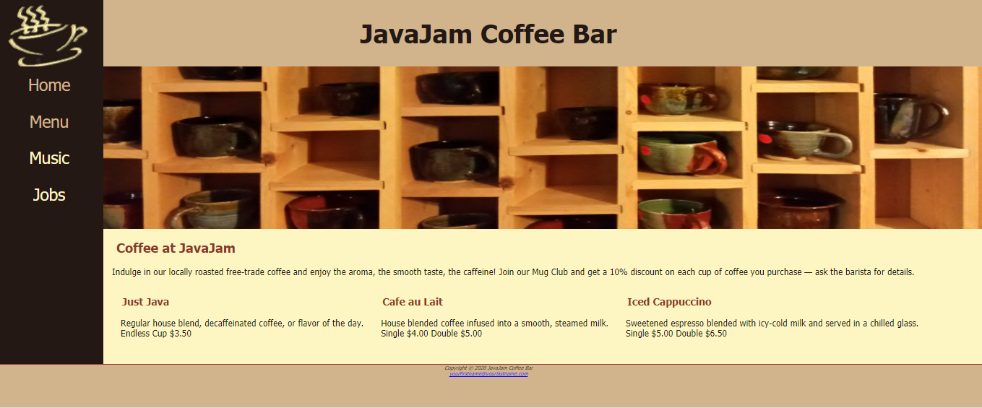

**Tablet**

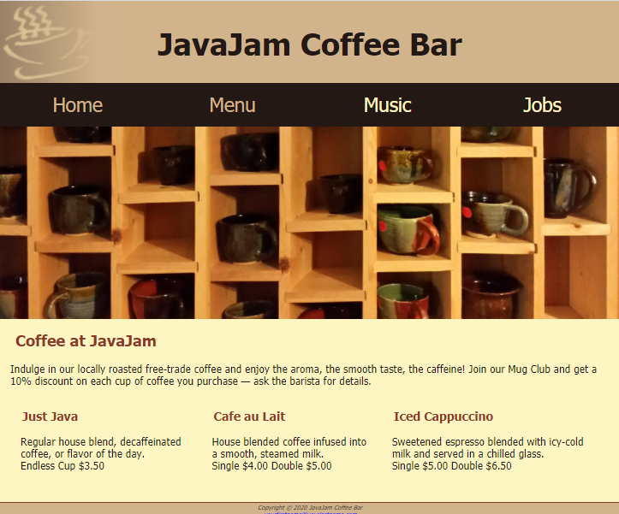

**Mobile**

